# **Coding Task (for ML Interns)**

**Challenge:**

Machine Learning Algorithms have made it possible to learn complex patterns in the data. Have you ever thought that an ML Algorithm can be used instead of a mathematical equation? Let's find out.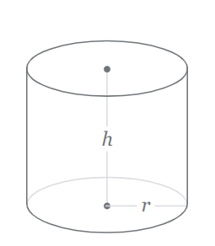

You are required to create a ML Model that can solve a mathematical equation i.e., Surface Area of Cylinder: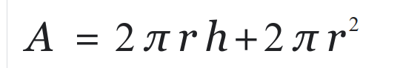

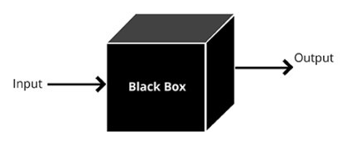

In this case, the ml model acts as a black box which takes **radius r** and **height h** as inputs, learns the patterns which maps accurately to the output i.e., **Surface Area A**.

Your tasks in the pipeline can be further divided into following sub-tasks:

1. Generate a dataset, based on the described input and output pairs. Further split into train and test sets.  
   **Note**: Size of the dataset is an open question at your end, that you will be required to find out based on the complexity of the problem.
2. Choose any two models i.e. Linear Regression, SVM, Random Forest, Neural Network etc. You are allowed to choose any ML/DL Framework and Library.
3. Train and Evaluate both the models.
4. Create an inference script which should take radius and height as input, feed it to your trained mode and output the Surface Area.

**Deliverables:**

1. Datasets split i.e. train and test in CSV Format
2. Machine Learning Models
3. Training Script/Jupyter notebooks
4. Inference Script
5. README.md file to reproduce the steps
6. Zip all the required files and submit.